ROLL CALL
VOTING: YES NO
Mayor Ben Hillyard (tie only) [ ] [ ]
Council Member Brian Hutchings [ ] [ ]
Council Member Steve Johns [ ] [ ]
Council Member Janet Lunt [ ] [ ]
Council Member Kari Malkovich [ ] [ ]
Council Member Dan Roden [ ] [ ]

I move that this Ordinance be adopted.

______________________________
Council Member

I second the foregoing motion.

______________________________
Council Member

Ordinance 2026-09

An Ordinance Amending City Code 10-8-10 Lighting

WHEREAS, the Woodland Hills City Planning Commission has reviewed and made a recommendation to the City Council to amend Woodland Hills Municipal City Code Title 10-8-10; and

WHEREAS, a public hearing before the Planning Commission of Woodland Hills City was held on January 21, 2026, after being duly advertised as required by law; and

WHEREAS, the City Council of Woodland Hills City finds that said amendment of the Woodland Hills Municipal City Code Title 10-8-10 Lighting.

NOW, THEREFORE, BE IT ORDAINED by the City Council of Woodland Hills City, Utah, that the City Code 10-8-10 Lighting be amended to read:

Intent of lighting ordinance: The purpose of the Woodland Hills lighting ordinance is to establish regulations and guidelines for outdoor lighting that enhance public safety and security while preserving the night sky.

Any light source which exceeds one thousand one hundred (1,100) lumens (75-watt incandescent bulb, 13-watt LED or equivalent) must have its light source shielded such that:

- The Useful Light may not be directed outside of the lot it is on. Spill light may leave the lot, but the lighting design should limit spill that affects other residents. Lighting fixtures must be fully shielded or recessed if the light is greater than 75 watts incandescent or 12 watts LED or equivalent.

See Diagram:

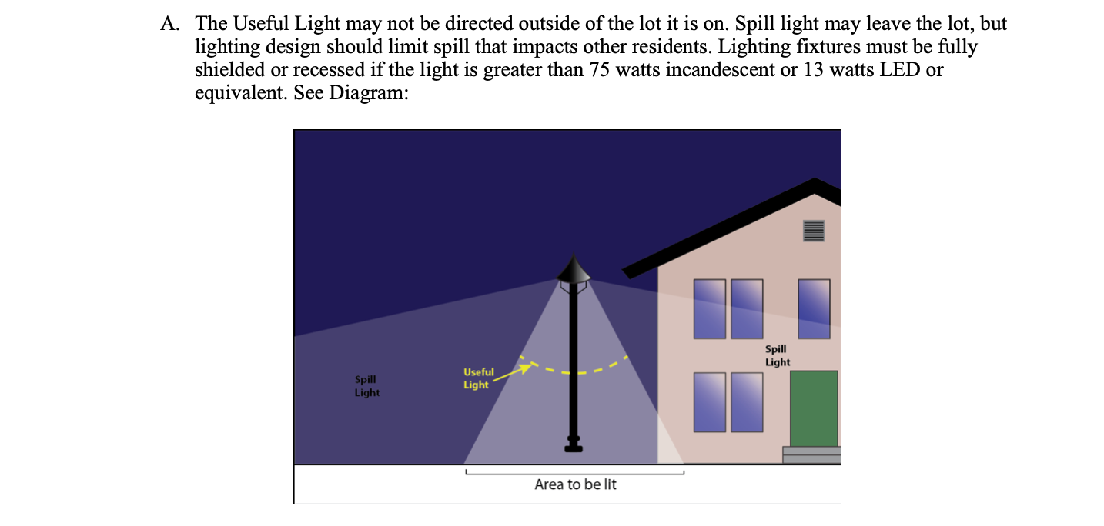

- Uplighting for landscaping and/or structures shall be avoided whenever possible, except in the displaying of a United States, State, or City flag.

- The lighting element is not shining directly on any surface (such as a wall) that would amplify its light output. (Note: This says that a resident must shield their lights if they are brighter than 1,100 lumens. The city restricts lighting exceeding 1,100 lumens unless installed for security purposes, including on any city-owned property, and exceptions are noted in paragraph D of this ordinance. For comparison, the following information is provided:

- One thousand six hundred (1,600) lumens would be a one-hundred-watt (100-watt) bulb or a 16-18-watt LED light.

- Eleven hundred (1,100) lumens would be a seventy-five (75) watt incandescent bulb, or a 13-watt LED;

- Eight hundred (800) lumens would be a sixty (60) watt incandescent bulb or a 9-10 LED bulb; and

- Four hundred fifty (450) lumens would be a forty (40) watt incandescent bulb or a 6-watt LED bulb.

- Temporary lighting is approved for up to 24 hours, which may emit light stronger than 1100 lumens, for special outside productions, sporting events, and other similar activities, as long as no safety hazard is created.

- No streetlights shall be erected on city streets.

PASSED AND ADOPTED by the City Council of Woodland Hills, Utah, this ______ day of _________________, 2026.

_______________________________________
Ben Hillyard
Mayor of Woodland Hills, Utah

ATTEST:

_______________________________
Jody Stones, City Recorder

CERTIFICATE OF POSTING ORDINANCE
For the City of Woodland Hills

I, Jody Stones, the duly appointed Recorder for the City of Woodland Hills, hereby certify that copies of the foregoing Ordinance No. 2026- were posted at three public places within the municipality this __________th day _______________ of 2026 which public places are:

- Utah Public Notice Website
- Woodland Hills City Center, 690 S. Woodland Hills Drive
- Woodland Hills Website, www.woodlandhills-ut.gov

Dated this ______ day of _______________, 2026.

__________________________
Jody Stones, Recorder

