
Fee Schedule
Update as of June 24, 2025

ADMINISTRATIVE FEES

Records (GRAMA) Requests | Based on the lowest paid employee qualified to fill the request
Returned Checks | $25.00
Research Per Hour, 1-hour minimum | $35.00
Candidate Filing Fee | $35.00
Copies | $.25/copy
Credit Card Transaction Fee | 3%

FACILITIES RENTAL FEES and SPECIAL EVENT FEES

City Center
Non-profit Resident | $20.00/hour or $125.00 a day plus a $500.00 refundable cleaning deposit
Non-profit Non-Resident | $50.00/hour or $400.00 a day plus a $500.00 refundable cleaning deposit
For Profit Events (Residents only) | $50.00/hour or $400.00 a day plus a $500.00 refundable cleaning deposit

Park Pavilion
Resident ½ day | $50.00 with a $50.00 refundable deposit
Non-Resident ½ day | $60.00 with a $100.00 refundable deposit
*The city center or pavilion may be reserved without any charge if the event meets all of the following.
- The event needs to be non-exclusive.
- The event needs to be non-profit.
- The event must be a benefit to all residents of the community.

Special Event Permits
(Permit holder is responsible for all costs associated with police, fire, and emergency services)
Special Events Permit with <250 participants | $100
Special Events Permit with >250 participants | $200


WATER and SEWER FEES

Water Maintenance Fee | $78.00
Water Stand-By Fee | $39.00
Residential Water Usage Rates: Tier 1 (0 – 5,000)  Tier 2 (5,001– 20,000)  Tier 3 (20,001 – 30,000)  Tier 4 (30,001– 40,000)  Tier 5 (40,001– 50,000)  Tier 6 (50,001– 60,000)  Tier 7 (60,001– 70,000)  Tier 8 (70,001– 80,000)  Tier 9 (80,001– 90,000)  Tier 10 (90,001– 100,000)  Tier 11 (100,001 and above) | $1.00 per 1,000 gallons  $2.00 per 1,000 gallons  $2.25 per 1,000 gallons  $2.50 per 1,000 gallons  $2.75 per 1,000 gallons  $3.00 per 1,000 gallons  $3.25 per 1,000 gallons  $3.50 per 1,000 gallons  $3.75 per 1,000 gallons  $4.00 per 1,000 gallons  $6.00 per 1,000 gallons
Shut Off Notice | $25.00
Water Disconnect/Reconnect During Office Hours | $85.00/$85.00
Water Disconnect/Reconnect After Hours | $100.00/$100.00
Damaged Water Meters | Actual cost of meter + labor
Water Service Deposit- Owner | $200.00
Water Service Deposit-Renter | $400.00
Addt’l Deposit w/o Social Security # | $350.00
Sewer Base Rate-Residential | $97.18
Sewer Base Rate-Commercial | $115.05
Past Due Bills | 2% per month

SANITATION FEES

Residential Can | $18.50
Additional Residential Can | $15.00
Recycling Can | $24.50
Lost or Damaged Cans | The actual cost of can billed by WM to the City



CODE ENFORCEMENT FEES

Code Violation Fee | Fines can be up to those of a class B misdemeanor as adopted by Utah Code 76-3-301
Default/Administrative Code Enforcement Hearing Fee | $100.00

ANNUAL BUSINESS LICENSING FEES

Home-Based Business License (does not exceed residential impact) | $25
Conditional Use Application | $150

LAND USE APPLICATION FEES

Development Agreement | $500
Development Agreement Amendment | $500
Subdivision – Review | $1,000 +$150.00 per lot. Includes two reviews
Subdivision – Final Plat Additional Reviews | Hourly rates will be charged to the developer.  City Engineer $170.00/hour
Plat Amendments | $1000 after final approval
Recording Fees | As charged by the Utah County Recorder
Annexation Request | $1500 Includes: application, two (2)staff reviews, two (2)engineering/planner reviews, planning commission and city council consideration, resolution, and recordation.


LAND USE APPLICATION FEES (cont.)

Lot Line Adjustment/Delineation | $150.00
Rezone Request | $300.00
Excavation Permit | $200-$500 depending on the scope of project  (See policy for details)
Variance Request | $500 deposit. The applicant is responsible for costs billed to the city by the Appeal Hearing Officer.
Land Use Appeals | $500 deposit. The applicant is responsible for costs billed to the city by the Appeal Hearing Officer.
ADU Application | A one-time fee of $500.00, which covers up to four (4) inspections. Additional inspections will be billed to the applicant at $100/inspection.
Yearly Fee to test a driveway or private road gate | $150.00

WATER DEPARTMENT FEES

Fire Hydrant Meter Rental Deposit | $2000
Daily Rate – Fire Hydrant Meter | $10.00 per day/$100.00/ month
Water Rate – Fire Hydrant Meter | $2 Per 1,000 gallons of water
Illegal Connection to Water System | $2,000 per occurrence

BUILDING PERMIT FEES

Building Permit Application Fee | $200
Site Plan Review Fee (Initial fee covers two reviews.) | $200

BUILDING PERMIT FEES (cont.)

Fire Inspection Fee | $150
Plan Review Fee | 65% of the Building Permit Fee
Building Fee | (Figured on square footage) based on ICC Tables
State Fee | 1% of Building Permit Fee
Water Impact Fee (2023 Impact Fee Study) | $5267.00
Water Connection Fee | $650.00
Sewer Impact Fee (Pass thru to Payson  City) | $7177.00
West Loafer Sewer Impact Fee  *See Exhibit A (2023 Impact Fee Study) | $3501
Sewer Hook Up | $200
IRC/IBC Code Appeal | $200-$500 depending on the extent of appeal (see policy for details)
Temporary Occupancy Certificate | $100
Temporary Building Permit | $200

INSPECTION FEES

Re-Inspection Fee | $100
Fire Inspection | $100
Working Beyond a Stop Work Order* | $200 per infraction
*Fines doubled for each subsequent infraction.


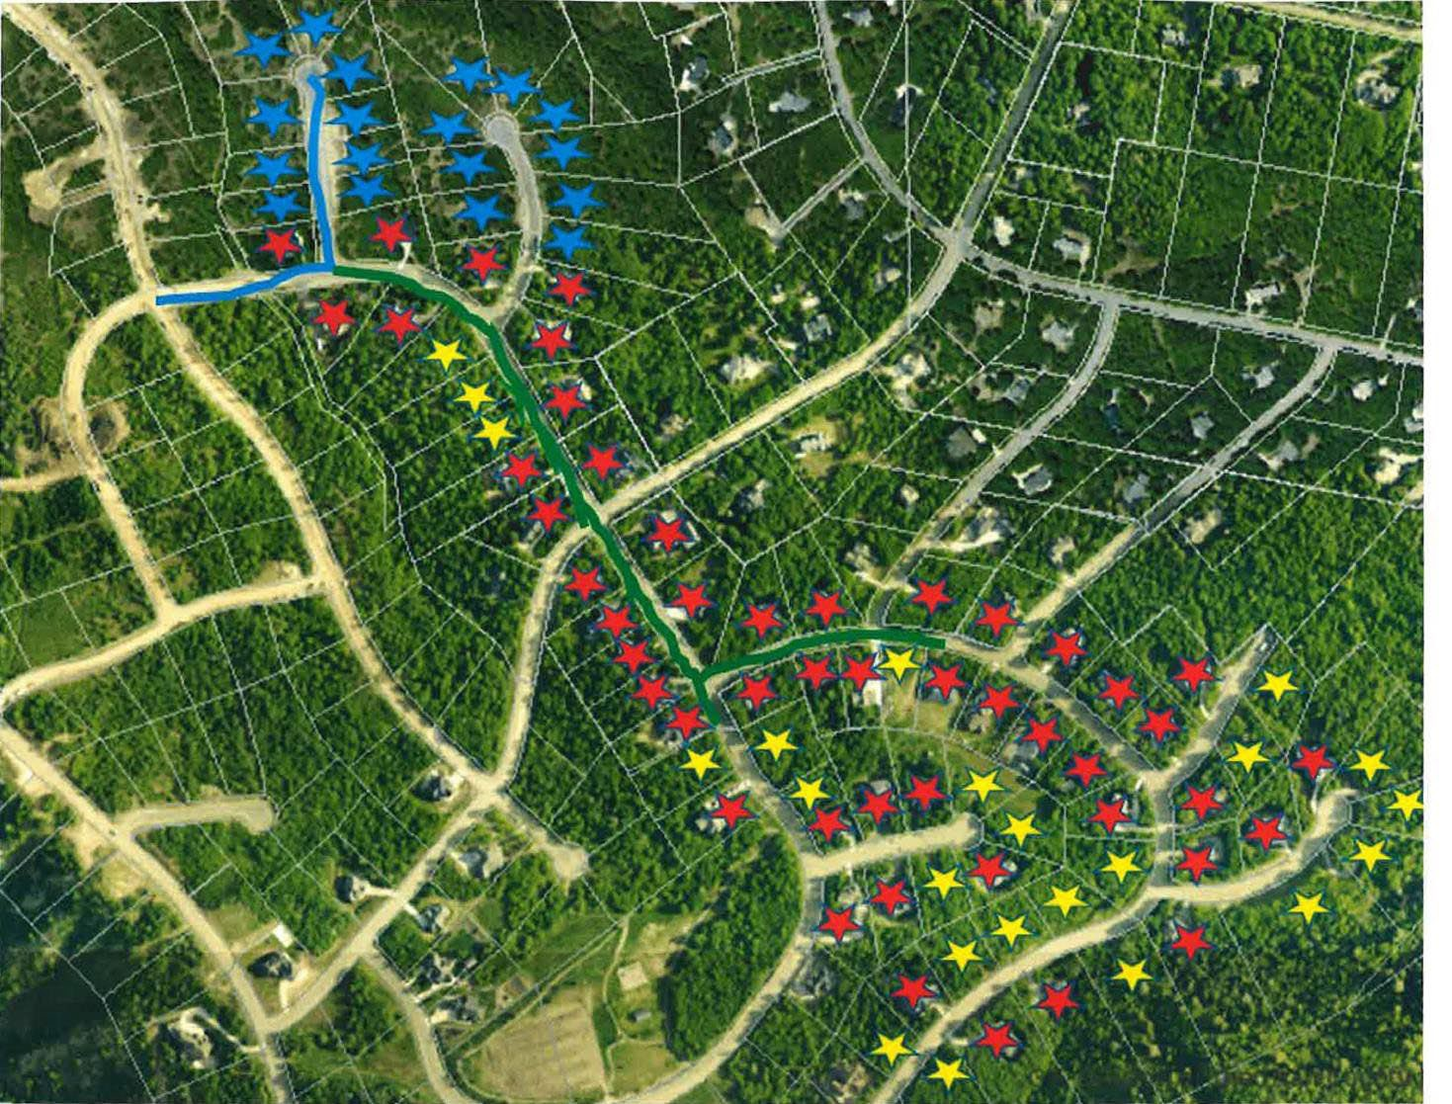
EXHIBIT A

